Introduction:
- The internet (a worldwide communication network), has changed our daily life in many ways.
- The WWW (World Wide Web), allows people to share the information.
- We are living in a digital world and we need to keep our information secured from attacks.
- To be secured, the information needs to be hidden from unauthorized access (Confidentiality), protected from unauthorized change (Integrity) and available to an authorized entity when it is needed (Availability).
- Examples of security violations:
- User “A” transmits a file to user “B”, which contains some sensitive information. user “C”, who is not authorized, is able to monitor the transmission and capture a copy of the file.
- “D” (A network manager), transmits a message to “E” (A computer under its management). That message instructs “E” to update an authorization file to include the entries of new users who are given access to that computer. User “F” intercepts the message, changes the entries of new users and then forwards the message to “E”, which thinks that the message is coming from “D” and updates its authorization file accordingly.
- Rather than intercept that message, user “F” creates its own message with desired entries and forwards the message to “E”, which thinks that the message is coming from “D” and updates its authorization file accordingly.
- An employee is fired without warning. The personnel manager sends a message to a server system to invalidate the employee’s account. The server will post a notice to the employee regarding confirmation of action. That employee is able to intercept the message and delay it long enough to make a final access to the server to retrieve the sensitive information. The message is forwarded, the action taken and the conformation is posted. The employee’s action is unnoticed for some considerable time.

What is Cyber Security?
“Cyber Security” (or) “IT Security” are a set of techniques which protects our computers, networks, programs and data from unauthorized access or attacks that are aimed for exploitation.
(Or)
“Cyber Security” is the way of protecting internet based-connected systems (which includes hardware, software and data) from cyber-attacks.
(Or)
“Cyber Security” is the process of protecting and recovering our networks, devices, programs and data from cyber-attacks.

Cryptography:
- “Crypto” means “Hidden”.
- “Cryptography” means “Secret Writing”.
- It is one of the techniques, which is used for “Secure communication” in the presence of third parties.
- It is a method of protecting the information and transmits it in a particular form, so that for whom the information is intended, can read and process it.
- Applications of Cryptography includes: E-Commerce, Chip-based payment cards, Digital currencies, Computer passwords and Military communication.
- Basic terms of cryptography:
- Plain Text: The original message.
- Cipher Text: The transformed message.
- Cipher: An algorithm, which is used for conversion (Plain Text <-> Cipher Text).
- Key: A secret piece of information.
- Encipher (Encryption): It is the process of converting Plain Text in to Cipher Text.
- Decipher (Decryption): It is the process of converting Cipher Text in to Plain Text.
- Types of keys:
- Symmetric key (Private key): Sender and receiver use the same key.
- Asymmetric key (Public key): Sender uses one key and receiver uses another key.

Cryptanalysis:
- It is the study of analyzing the information systems in order to study the hidden aspects of the systems.
- It is used to breach the cryptographic security systems and gain access to the contents of encrypted messages, even if the cryptographic key is unknown.
- It uses mathematical formulas to search for vulnerabilities and break into cryptographic security systems.

Cryptology: It is the combination of “Cryptography” and “Cryptanalysis”.
Key Terms:
- Exploitable: Make use of or an advantage.
- Malicious: Intending to do harm.
- Vulnerability: It is a weakness in design, implementation, operation or control.
- Threat: Likely to cause damage (or) danger. It is a possible danger that might exploit vulnerability.
- Attack: An assault on system security that derives from an intelligent threat.
- Exploitable Vulnerability: Vulnerabilities are often exploited with the help of some automated tools (or) some customized scripts.

Security Goals:
- To secure the information, it needs to be hidden from unauthorized access (Confidentiality), protected from unauthorized change (Integrity) and available to an authorized entity, when it is needed (Availability).
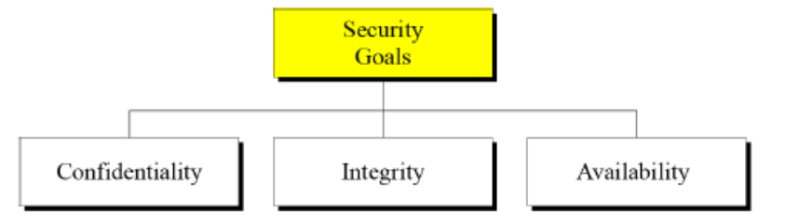
- Few decades ago, the information collected by an organization was stored on physical files.
- The “Confidentiality” of the files was achieved by restricting the access to a few authorized (or) trusted people in the organization.
- In the same way, only a few authorized people were allowed to change the contents of the files.
- “Availability” was achieved by designating at least one person who would have access to the files at all times.
- Now a days, instead of being stores on physical media, it was stored in computers. The 3 security requirements didn’t change.
- The files stored in computers require confidentiality, integrity and availability. The implementation of these requirements is different and more challenging.
- Confidentiality:
- We need to protect our confidential information.
- Confidentiality is not only applied to the storage of information, it also applies to the transmission of information.
- When we send a piece of information to be stored in a remote computer (or) when we retrieve a piece of information from a remote computer, we need to conceal (not allowed to be seen) it during transmission.
- Integrity:
- Information needs to be changed constantly.
- Integrity means that changes need to be done only by authorized entities through authorized mechanisms.
- In a bank, when a customer deposits or withdraws money, the balance needs to be changed.
- Availability:
- The information created and stored by an organization needs to be available to authorized entities.
- Information is useless, if it is not available.
- The unavailability of information is harmful for an organization, where it lacks confidentiality or integrity.
- Imagine what would happen, if the customers could not access their accounts for transactions.

OSI Security Architecture:
- It defines a systematic approach, which is useful to provide security.
- This architecture was developed as an international standard, which mainly focuses on security attacks, mechanisms and services.
Security Attacks:
- These are mainly classified into 2 types (i.e) Passive attacks & Active attacks.
- A passive attack, attempts to learn (or) make use of information from the system, but doesn’t affect the system resources.
- An active attack, attempts to alter system resources (or) affect their operation.
- Passive attacks:
In these types of attacks, their goal is to obtain the information that is being transmitted over the internet or any other communication. These attacks are very difficult to detect, because they do not involve any alteration of data. Typically, the message is sent and received in a normal fashion and neither the sender nor the receiver is aware that a third party has read the messages or observed the message patterns.
- Release of message contents (Snooping):
- A telephonic conversation, an email message and a transferred file may contain sensitive (or) confidential information.
- We have to prevent an opponent from learning the contents of these transmissions.
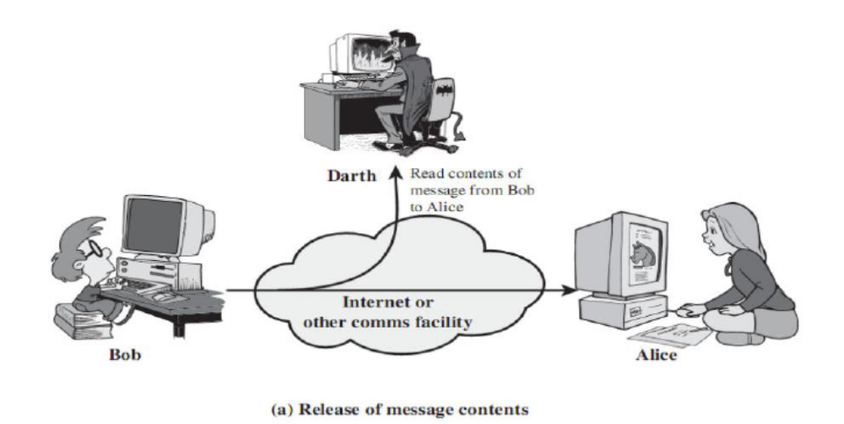
- Traffic Analysis:
- It defines the way of masking the contents of messages, so that, if the opponents captured the message, they could not extract the information from the message.
- The common technique for masking the contents is “Encryption”.
- After encryption also, an opponent might still be able to observe the pattern of messages.
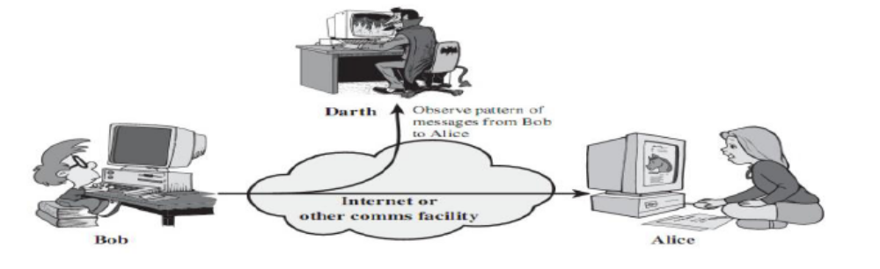
- Active Attacks:
These attacks involve some modifications of messages (or) the creation of false message. It is quite difficult to prevent.
- Masquerade (Spoofing):
- In these kinds of attacks, one entity is pretending to be a different entity.
- This attack usually includes one of the other forms of active attack.
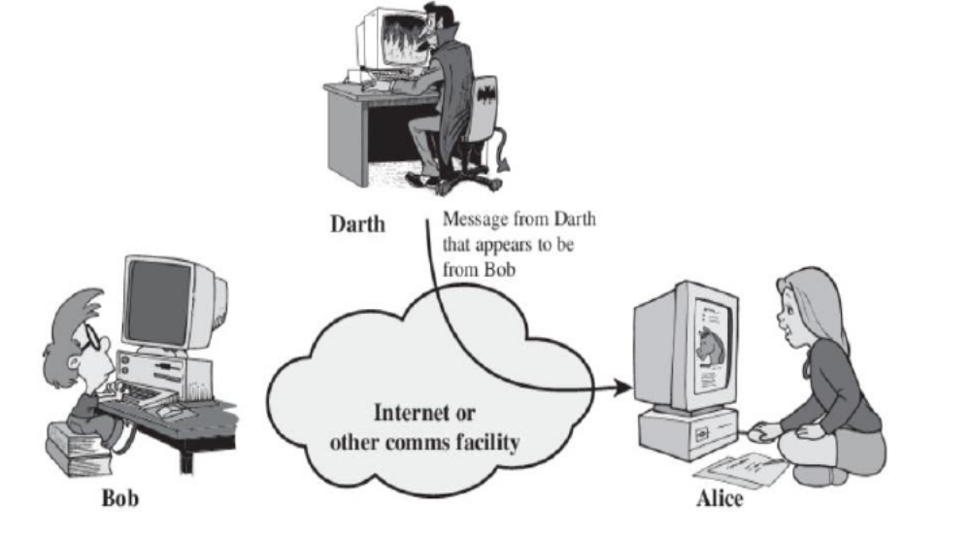
- Replay:
- In these kinds of attacks, the attacker captures a copy of a message sent by the user and later tries to replay it.
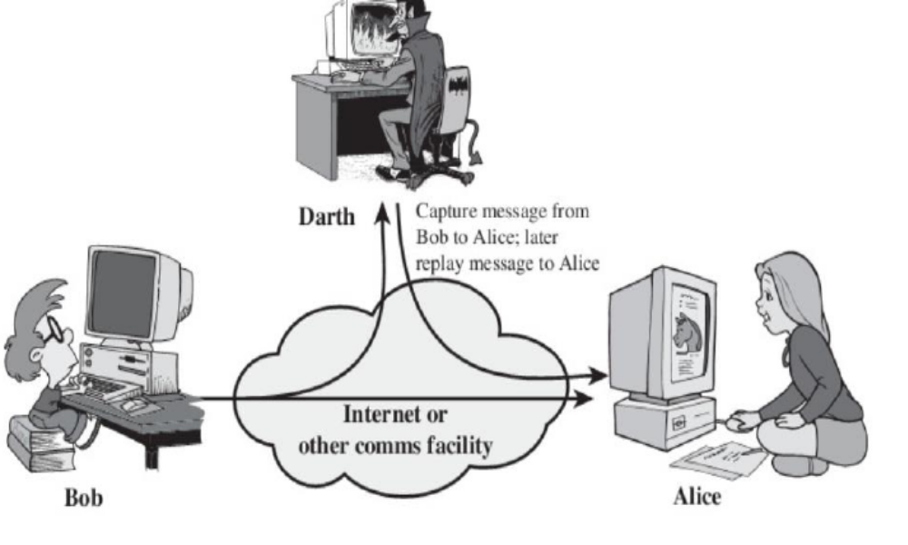
- Modification of messages:
- In these kinds of attacks, some portion of a message is being altered (or) the messages can be delayed (or) the messages can be reordered, to produce an unauthorized effect.
- For example, a message includes “Allow Smith to read the confidential file accounts” is modified to mean “Allow John to read the confidential file accounts”.
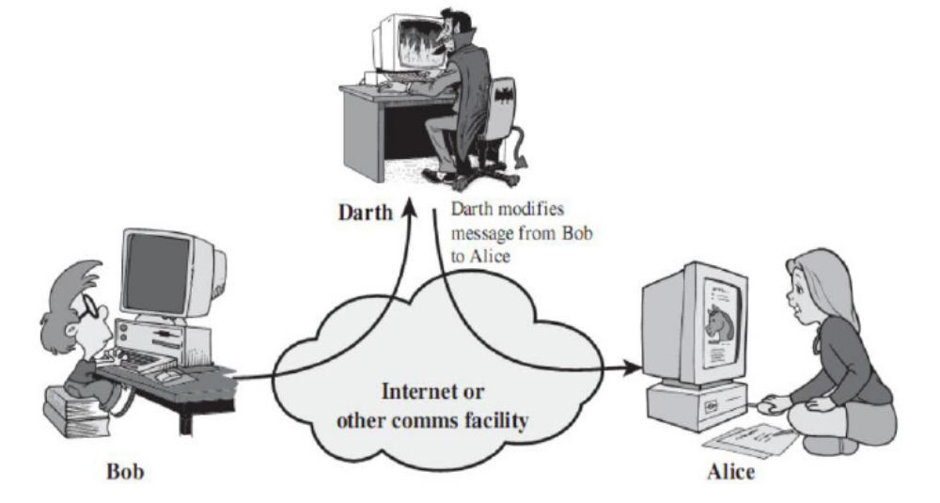
- Denial of service:
- These kinds of attacks, prevents the normal use of communication facilities.
- These attacks may have a specific target.
- For example, an entity may suppress (Prevent) all the messages directed to a particular destination (or) disruption of an entire network.
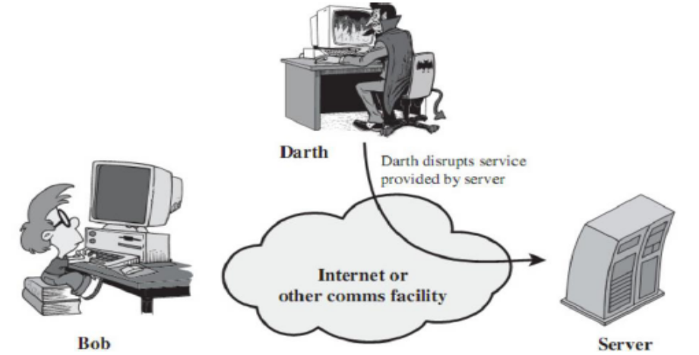

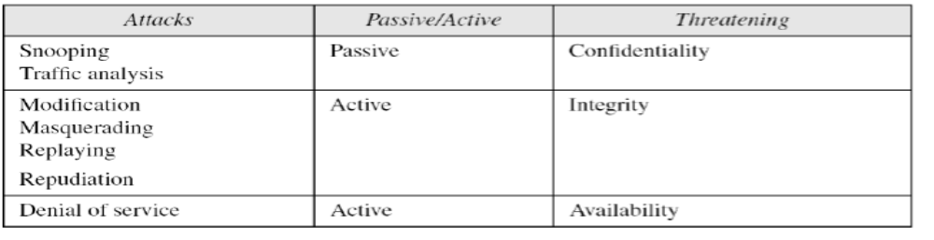

Security Services:
- A Processing (or) Communication service that is provided by a system to give a specific kind of protection to the system resources.
- Security services implement Security policies and are implemented by security mechanisms.
- These services are divided into 5 categories:
- Authentication.
- Access Control.
- Data Confidentiality.
- Data Integrity.
- Nonrepudiation.
- Authentication:
- This service is concerned with “assuring that a communication is authentic”.
- In the case of single message, the function of this service is to assure the recipient that the message is from source.
- In the case of ongoing interaction, at the time of connection initiation, the service assures that the 2 entities are authentic and it also assures that the connection is not interfered by the third party.
- Peer entity authentication:
- It provides for the confirmation of the identity of a peer entity.
- It attempts to provide confidence that an entity is not performing either a masquerade or a replay.
- Data origin authentication:
- It provides for the confirmation of the source of a data unit.
- It doesn’t provide protection against the duplication or modification of data.
- This type of service supports applications like email, where there are no prior interactions between the communicating entities.
- Access Control:
- The ability to limit and control the access to host systems and applications via communication links.
- To achieve this, each entity who is trying to gain access must be identified, so that access rights can be tailored (Fit) to the individual.
- Nonrepudiation:
- It prevents either sender or receiver from denying a transmitted message.
- When a message is sent, the receiver can prove that the alleged sender sent the message.
- Similarly, when a message is received, the sender can prove that the alleged receiver received the message.
- Data Confidentiality:
- Confidentiality is the protection of transmitted data from passive attacks.
- With respect to the contents of a data transmission, several levels of protection can be identified.
- The broadest service protects all the user data transmitted between 2 users over a period of time.
- The narrower forms of this service, protects a single message or even specific fields within a message.
- The other aspect of confidentiality is the protection of traffic flow from analysis. The attacker not able to observe the source, destination, frequency, length or other characteristics of the traffic.
- Data Integrity:
- As with confidentiality, integrity can also be applied to a stream of messages, a single message or the selected fields within a message.
- A connection-oriented integrity service, deals with a stream of messages, and assures that messages are received as sent, with no duplication, insertion, modification, reordering or replays. This service addresses both modification and denial of service.
- A connectionless integrity service, deals with individual messages and provides protection against modifications only.

Security Mechanisms:
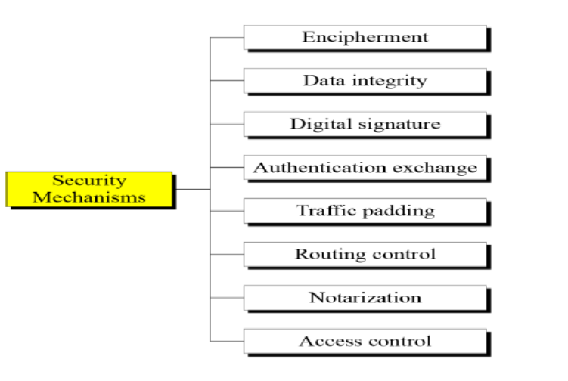
- Encipherment:
Hiding or covering of data can provide confidentiality. The use of mathematical algorithms to transform the data into a form that is not readable. Today, Cryptography & Steganography are used for enciphering.
- Data Integrity:
This mechanism appends a short checkvalue to the data, that has been created by a specific process. The receiver receives the data and the check value. He creates a new checkvalue from the received data and compares it with the received one. If both are same, the integrity of data has been preserved.
- Digital Signature:
The sender can electronically sign the data using private key and the receiver can electronically verify the signature using sender’s public key. The receiver uses sender’s public key to prove that the message is signed by the sender, to claim that the sender has sent the message.
- Authentication Exchange:
In this mechanism, 2 entities exchange some messages to prove their identity to each other.
- Traffic Padding:
It means inserting some bogus data into the traffic flow, to prevent the opponent’s traffic analysis.
- Routing Control:
Selecting & continuously changing different available routes between the sender and receiver to prevent the opponent from eavesdropping (Silently observing the communication).
- Notarization:
It means selecting a trusted third party to control the communication between the 2 entities, to prevent repudiation.
- Access control:
It uses some methods to prove that a user has access rights to access the data or resources.

Relation between security services & mechanisms:

